Cassandra Rousseau, Zi Di Zhu, Hummam Houara

[Project link](https://zidizhu.github.io/CART360/VCMCdocs.html)

[Prototype repository link](https://drive.google.com/drive/folders/1ebUWGLb5xc49yvKLds1cu7j0YYUs8L4l?usp=sharing)

**Prototype —**

**Everywhere = Nowhere = Now**

**Vibe Check Music Controller**

CART 360: Tangible Media & Physical Computing

Elio Bidinost

November 5, 2021

## **Diagram**

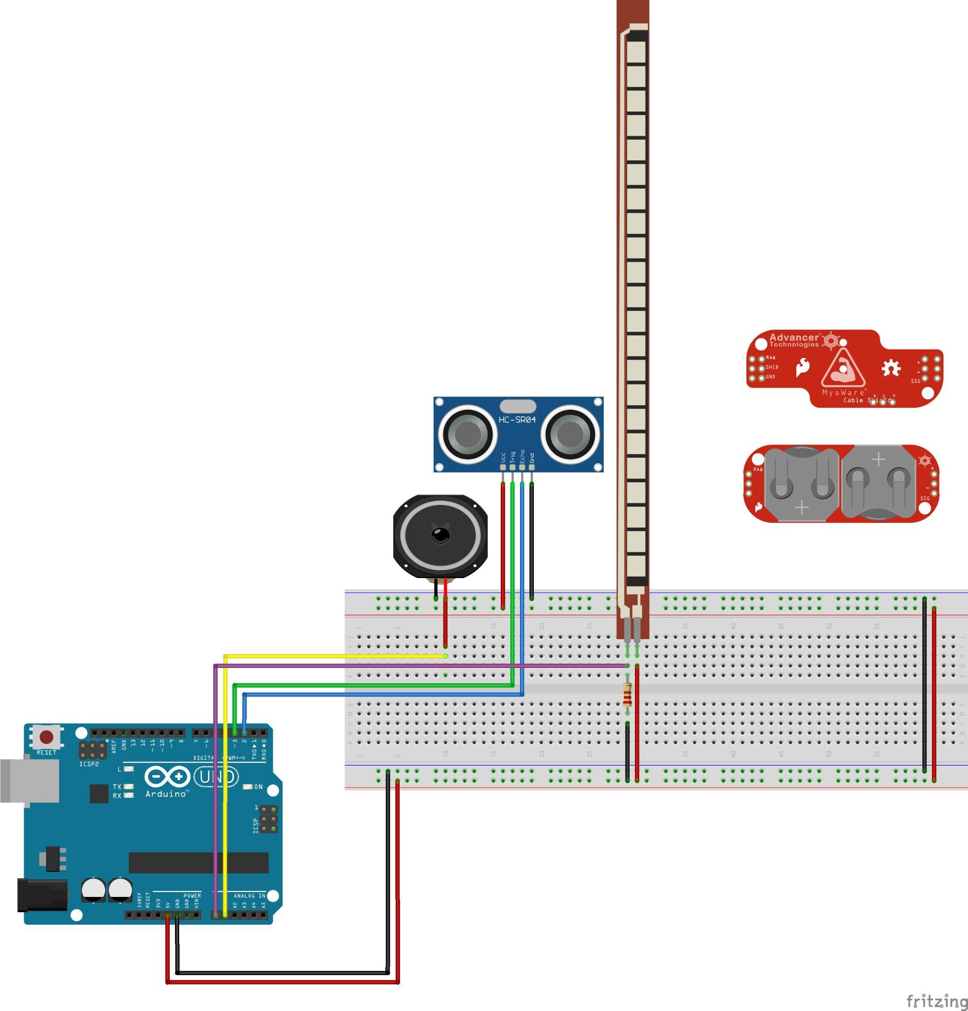

## **Simple Guide to the Current Features:**

* When it turns on, it will start playing an ascending sequence of notes.
* Move hand (or object) perpendicular to the ultrasonic distance sensor to change the chord of notes. Different distances give different chords
* Place hand very close to the distance sensor (less than 5cm) to change the beat pattern
* Bend the flex sensor to make the tempo slower

## **Parts:**

A1: Speakers:

Loops a sequence of notes. We have a few arrays of different notes (different chords), and different patterns for the notes to be played.

A0: Flex sensor:

Outputs an int between 0-180.

The base duration of a note is 120 millis, but the more this sensor is flexed, the longer the duration of the note is.

2,3: Ultrasonic Distance sensor:

Outputs the distance between the sensor and an object.

The distance is mapped to different chords of notes: The further the distance, the higher pitches are.

If the distance <5cm, it changes the beat pattern.

* The myoware is to be added later

* The parts will be placed on a glove

## **Potential features to add/ alternative designs:**

Here are some features that are not in this prototype, but could be tested:

* Have a “record” function that records everything that has been played.
* Use buttons to allow the user to customize their own beat pattern.
* Adding the myoware sensor that controls the oscillation of the note’s frequency
* Multiple microcontrollers on a wireless network
* Include Mozzi Library to have different “textures” of sounds

**How *Why Do We Prototype?* & *Fidelity Levels* relates to the development process of our Physical Prototype**

Multiple aspects in our project relate to the prototype making process and its fidelity levels. The methods mentioned in *Prototyping for Physical and Digital Products* by Kathryn McElroy align with our design process. Prototyping is the best way to improve the project for the users. By testing multiple ideas, we can get the best result for what we intended. Prototyping was useful for us to make some improvements on our model, fix some technical issues and to test if our intentions work in practice. In our project, we tried to create interactive parts and mechanisms that are close to the intended final product. We separated the process into multiple layers: researching and sketching, testing the materials, combining the materials and creating the final prototype. Our team agreed to start with the glove as our main prototype using at least two features requiring sensors. Our low fidelity was creating sketches of our intended project with the required sensors and searching information about these sensors. We started by creating sketches of what we intended to create as a wearable textile. We did deep research about the characteristics of different sensors and how to use them. We also ask some advice from people working in the fashion industry and doing some research about which fabric might be the best to use in this project. The mid-fidelity level was to test the sensors that we found closer to our intentions and create a working circuit for each. The chosen sensors were the Myoware sensor, a force sensitive resistor, an ultrasonic sensor and a flex sensor. We tested each sensor with their own circuit and code virtually with the browser-based app Tinkercad. The first sound attempt was basic coded input and output. We used some Arduino code examples as references depending on the sensor we tried to code. Once we created a working virtual circuit, we transferred the code onto the Arduino IDE and tried to build a physical version of the designed circuit. We wanted to ensure that the sensors were appropriate to produce sounds and if the connection between the sensors and the buzzers was doable. Regarding the glove, we tried multiple fabrics to find which one might be the best to use in our context. Our first attempt was to use polyester to create the wearable textile. We decided to use this fabric first due to our research and the feedback we got from people working in the fashion design field. However, using polyester was not a success; it was harder for us to sew this fabric due to our poor experience using sewing machines. Our second attempt was an organic fabric. Unfortunately, we found out that this fabric was not rigid enough to support our components on the glove. We decided then to use a stiffer fabric, which was felt. We found this fabric rigid enough to support the components but uncomfortable for the user. Our final idea was to make our top layer with polyester, allowing it to fit different hand sizes, and the under layer with felt to hold most of our components. Our high fidelity prototype was the fully coded interactivity of the wearable textile and the final result of the glove. After some adjustments in both the codes and the circuits, we started to build the code and a physical circuit combining the sensors together and adding variations in the sound. Regarding the glove, we decided to create the mixed fabric glove. It represented really well our intention to make it usable by different persons and to hold the components on the glove properly. Unfortunately, we did not got the time to add the circuit onto our glove.

**Has your Project’s initial intention or supposed meaning changed over the course of researching and implementing the Physical Prototype?**

The project's initial intention and meaning changed throughout researching and implementing the physical prototype for various reasons. After our first presentation, the feedback given for our proposal changed the path we wanted to take a lot. We had to change the interface and its characteristics to make our project more challenging and interactive. We still kept the idea of creating music through bodies but in a different manner. The second idea was to create a wearable computing glove and a high sock containing sensors on or within them. Each wearable textile has its own Arduino, holding its sound library. A loop of computer-generated sounds will vary depending on the pressure, movement axis, and muscle contractions. The purpose was to allow a new way of composing music without using a traditional approach. To push the project further, we wanted to install a Kinect connected to its own Arduino and sound library that detects the user’s location in the environment. The melody will change according to the user’s position in the room. We removed this idea because we thought it might be a too direct approach to what we intended to do due to its integrated camera already reading RGB colours, body types and facial features. Another idea was to create a carpet that detects the X and Y position of the user. The computer-generated melody varies depending on the user’s position. The carpet will have its own Arduino and sound library. This idea was removed the amount of time required to do the project. We researched multiple possible sensors for our project and if the sensors in our Arduino kit can fit the idea of creating music through bodies. We selected the Myoware sensor, a force-sensitive resistor, an ultrasonic sensor and a flex sensor. We thought these components' abilities to react to flexion, pressure, motion and muscle contraction could allow interesting music composition from the user. We removed the idea of using temperature and heart rate sensors due to being too passive components for our project’s intention. We wanted to add more components to our project, but we had to reduce our scale due to their total cost. We tried to contact FASA to apply for a grant, but we never had an answer from them. We removed the idea of using the Ableton software due to being a too direct approach to what we intended to do. After proposing our second idea, other ideas arise to add or modify our project to make it more interesting. At first, we thought that the same user wore the glove and the socker. However, putting every feature on the same user might be overwhelming. So it was decided to separate the glove and the sock on different users. We wondered how to maintain the components of the wearable textiles; we thought of either soldering or sewing the components. We were suggested to sew the pieces with conductive threads and use an Adafruit Flora. To make our sound library more varied and interesting, the teacher suggested creating the Mozard microcontroller and using the Mozzi library. The last suggestion was to connect both the glove and the sock by radio frequencies and make them interact and communicate; the wearable textiles react and get influenced by each other's movements and pressure. After these suggestions, we asked people working and studying in the fashion industry and did some research. We decided to use Polyester to create wearable textiles due to being synthetic fabric and its flexible nature. However, while trying to sew the glove for the prototype, we noticed it would be too hard to create it with this fabric due to the poor experience of our team in sewing. We tested multiple fabrics and concluded to combine the polyester and its stretchable characteristic to make it fit various hand sizes and felt due to its rigidity to hold the components on the glove.